Design, Build and Testing of a 3D Hologram-like RGB LED Fan Display

Mechatronics Project 478
Final Report

Teagan Reddy
26012243

Supervisor
Dr Melody Neaves

2026

Plagiarism declaration
I have read and understand the Stellenbosch University Policy on Plagiarism and the definitions of plagiarism and self-plagiarism contained in the Policy [Plagiarism: The use of the ideas or material of others without acknowledgement, or the re-use of one's own previously evaluated or published material without acknowledgement or indication thereof (self-plagiarism or text-recycling)].
I also understand that direct translations are plagiarism, unless accompanied by an appropriate acknowledgement of the source. I also know that verbatim copy that has not been explicitly indicated as such, is plagiarism.
I know that plagiarism is a punishable offence and may be referred to the University's Central Disciplinary Committee (CDC) who has the authority to expel me for such an offence.
I know that plagiarism is harmful for the academic environment and that it has a negative impact on any profession.
Accordingly all quotations and contributions from any source whatsoever (including the internet) have been cited fully (acknowledged); further, all verbatim copies have been expressly indicated as such (e.g. through quotation marks) and the sources are cited fully.
I declare that, except where a source has been cited, the work contained in this assignment is my own work and that I have not previously (in its entirety or in part) submitted it for grading in this module/assignment or another module/assignment.
I declare that have not allowed, and will not allow, anyone to use my work (in paper, graphics, electronic, verbal or any other format) with the intention of passing it off as his/her own work.
I know that a mark of zero may be awarded to assignments with plagiarism and also that no opportunity be given to submit an improved assignment.

Signature: 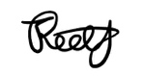

Name: Teagan Reddy Student no: 26012243

Date: 20/07/2026

AI Use Declaration
I am convinced and can support my claim that my assessment product is an indication of my own learning, knowledge, skills, and understanding.
Where I have used AI tools for enhancing my own creation of ideas and words, I acknowledge that I have to declare it.
Where I have used AI tools for generating new ideas, words, code, image-prompts for other AI Image-generating tools, or structure and even presentations (or other AI tools that can be used as assistants to the knowledge building and representing process), I have declared and documented the use of such tools and I am pre- pared to talk about the process I used and what it contributed to my learning and insights.
I am aware that the lecturer can ask me to demonstrate my learning, for example through explaining the choices I made in terms of approach, content used, literature selected, conclusions drawn, etc. through an additional assessment like an oral (for example).
I understand that if I am not able to agree to the above points, there is a chance that my academic behaviour will be deemed unethical and might lead to a disciplinary case being brought against me on the grounds of cheating or plagiarism and that the standard procedures for such behaviour will be followed.
As per the Disciplinary Code of SU (par. 10.2.1 and 10.2.2), I understand that I take responsibility for the integrity of my work, which includes the obligation to ask for clarification from an academic member of staff if I am unsure of anything, and that I strictly adhered to all instructions received in the course of the academic assessment by relevant and authorized staff (whether the instruction is in oral or written format).
I understand that when I am not able to document and declare my use of AI tools, this behaviour will be deemed as cheating in examinations and assessments (Disciplinary Code 1.1 c.) as I referred to “unauthorized notes, books, electronic devices or other reference material”.

Signature: 

Name: Teagan Reddy Student no: 26012243

Date: 20/07/2026

Executive Summary
Title of Project
Design, build and testing of a 3D hologram-like RGB fan display
Objectives
The project objectives are to formulate specifications for an affordable 3D hologram-like RGB LED fan display unit, generate and evaluate design concepts aligned with those specifications, select suitable and safe materials and components for the final design, develop and integrate the required software and user-interface, and test the unit using a range of static and dynamic visual display inputs.
What is current practice and what are its limitations?
Modern 3D LED fan displays are primarily used in high-end advertising and digital signage. These units are expensive and rely on proprietary technology, which prevents their use for educational and recreational purposes. Commercial units often lack integrated safety features which is a concern for these displays when they are used in public spaces.
What is new in this project?
This project presents the design, build and testing of a safe and affordable 3D hologram-like RGB LED fan display unit capable of synchronous operation and the rendering of both static and dynamic visual scenes.
If the project is successful, how will it make a difference?
This project will contribute to the use of 3D hologram-like displays by improving the quality and availability of hologram-like displays at the lower end of the market.
What are the risks to the project being a success? Why is it expected to be successful?
The risks of the project can be categorised into three parts: time constraints, budget constraints and the advanced hardware-to-software integration required. These risks are mitigated through strategies such as effective and detailed project planning to manage the time and budget constraints, and comprehensive market research to identify low-cost and efficient solutions to satisfy the component requirements.
What contributions have/will other students made/make?
A previous Stellenbosch student (Botes, 2025) has completed this project in the previous academic year.
Which aspects of the project will carry on after completion and why?
Future students could include real-time wireless content streaming or increased LED density for improved display resolution.
What arrangements have been/will be made to expedite continuation?
The physical display unit will be manufactured as a modular and portable system to support any future hardware alterations. Furthermore, all design decisions, calculations and developed software will be documented and included in the project file.

Acknowledgements
(Intentionally left blank)

Table of Contents
Page
Plagiarism declaration i
AI Use Declaration ii
Executive Summary iii
Acknowledgements iv
Table of Contents v
List of Figures vii
List of Tables viii
List of symbols ix
1 Introduction 1
1.1 Background 1
1.2 Objectives 3
1.3 Motivation 3
1.4 Use of Generative AI 4
2 Literature review 5
2.1 Volumetric and POV Display Technologies 5
2.2 The POV Effect 6
2.3 Applications and Market Context 7
2.4 Power Delivery and Dynamic Rotor Balancing 8
2.5 Embedded Systems and Motor Control 9
2.6 Software Architecture and Image Processing 9
3 System Specifications 11
3.1 Stakeholder Requirements 11
3.2 Functional Requirements 13
3.3 Technical Performance Measures 14
4 Concept Design 16
4.1 Hardware Concept Design 16
4.1.1 Hardware Concept 1: Linear Rail Mounted Assembly 16
4.1.2 Hardware Concept 2: Trunnion Mount Assembly 17
4.1.3 Hardware Concept 3: Fully Enclosed Assembly 18
4.2 Electronic Concept Design 19
4.2.1 Electronic Concept 1: Decoupled, Battery Powered System 20
4.2.2 Electronic Concept 2: Slip Ring System 21
4.2.3 Electronic Concept 3: Wireless Power System 22
5 Concept Evaluation 23
5.1 Hardware Concept Evaluation 23
5.2 Electronic Concept Evaluation 25
6 Detail Design 27
6.1 Design Overview 27
6.2 Linear Rail Subsystem 29
6.3 Stator Subsystem 30
6.4 Rotor Subsystem 31
References 33

List of Figures

Page
Figure 1: Lumina 17-inch hologram-like LED fan display with protective guard (Lumina, 2026) 1
Figure 2: ESP32-based spherical POV display (Welsh, 2020) 6
Figure 3: Hologram-like fan used in the classroom (Ortega et al., 2020) 7
Figure 4: Image conversion between Cartesian and polar coordinates (Lee et al., 2024). (a) Image in the discrete Cartesian coordinate. (b) Image in the discrete polar coordinate. 10
Figure 5: Linear rail CAD model 16
Figure 6: Trunnion style bracket CAD model 17
Figure 7: Fully enclosed concept CAD model 19
Figure 8: Decoupled, battery powered flow diagram concept 20
Figure 9: Slip ring flow diagram concept 21
Figure 10: Wireless power flow diagram concept 22
Figure 11: CAD model of final system assembly 27
Figure 12: CAD model of linear rail subsystem 29
Figure 13: Stator subsystem CAD model 30
Figure 14: Rotor subsystem CAD model 31
Figure 16: Gantt Chart of Planned Activities 37

List of Tables

Page
Table 1: Stakeholder Requirements 11
Table 2: Functional Requirements 13
Table 3: Technical Performance Measures 15
Table 4: Decision Matrix for Hardware Concepts 24
Table 5: Decision Matrix for Electronic Concepts 26

List of symbols

A Wing area
c Chord length
α Angle of attack

Introduction

Background
Advancements in visual display technology have transformed the way information is presented in modern society, ranging from educational tools to commercial advertising platforms. Among emerging display technologies, hologram-like fan displays have attracted considerable attention due to their ability to render three-dimensional (3D) objects in free space. Although these displays are often referred to as “holographic,” they do not rely on true holography. Instead, they exploit the persistence of vision (POV) phenomenon, a visual perception effect in which rapidly moving light sources create the illusion of continuous images to the human eye. POV occurs when the human eye retains an image for a short duration after the stimulus has disappeared (Paul et al., 2013).
By rapidly rotating a strip or array of light-emitting diodes (LEDs) and precisely controlling their illumination timing, a two-dimensional (2D) image can be rendered in free space. When the rotational speed is sufficiently high, the discrete light pulses produced by the LEDs blend, forming the perception of a stable and 3D visual display. This technique enables the creation of static and dynamic images (Mishra et al., 2021). Static scenes refer to fixed images such as logos or text, while dynamic scenes consist of animated content such as rotating objects or looping video sequences.
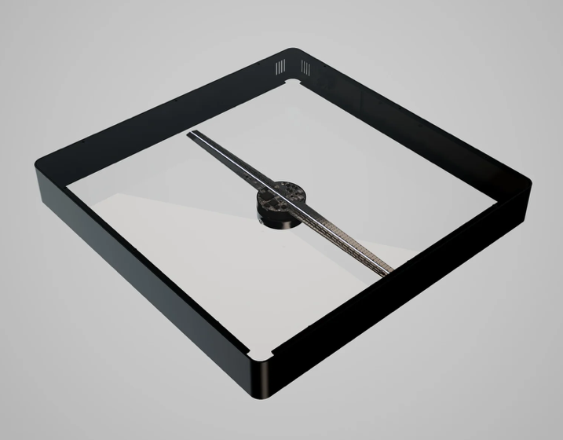

Figure 1: Lumina 17-inch hologram-like LED fan display with protective guard (Lumina, 2026)
Despite their visual appeal and growing popularity, commercially available hologram-like LED fan display units remain expensive and inaccessible for general use. This places the technology out of reach for many educational institutions and individual enthusiasts. Many existing systems are proprietary and rely on specialised hardware and software, limiting their adaptability for custom applications. Consequently, there is growing interest in the development of low-cost alternatives that can reproduce similar visual effects, while remaining accessible for educational demonstrations and recreational experimentation.
Furthermore, the unique floating and 3D visual effect produced by hologram-like LED fan displays creates an engaging viewing experience. This makes the technology particularly suitable for a variety of applications, including interactive classroom demonstrations and advertising displays (Fokides et al., 2023). Presenting graphics and animations in open space can enhance audience engagement and information delivery (Ortega et al., 2020).
Additive manufacturing (AM) overcomes the geometrical limitations typically associated with traditional manufacturing routes, by taking information directly from computer-aided design (CAD) files (Wong and Hernandez, 2012). In this project, AM will be used to produce a lightweight, balanced rotor and body design with integrated mounting channels for high-density RGB LED strips.
The development of a low-cost display unit has potential benefits beyond educational use. An important advantage of LED fan displays lies in their potential energy efficiency. Conventional screens, such as LED panels or LCD displays, require millions of illuminated pixels. However, a rotating LED fan display utilises a single strip of LEDs attached to a rotating arm, which can generate similar images while consuming less power when compared to conventional screens. This characteristic makes such displays attractive for commercial applications, particularly in advertising environments where large, attention-grabbing displays are required but energy consumption must remain manageable (Chandrika et al., 2017).
Therefore, this project aims to design, build, and test a low-cost 3D hologram-like RGB LED fan display system that leverages the persistence of vision effect. The system balances visual quality, affordability, portability, and energy efficiency, with custom control software for uploading and displaying visual content. This work forms part of Mr Teagan Reddy’s final year Mechatronics Engineering 478 Project. It will take place from 2 January 2026 until 6 November 2026. Experimental facilities within the Mechanical laboratory at Stellenbosch University will be used within a budget of R5000.

Objectives
Hologram-like LED fan displays present 3D imagery in open space and have demonstrated applications in education, advertising, and recreation. However, current commercial designs remain prohibitively expensive and have been developed with limited consideration for manufacturability, operational safety, and energy efficiency, restricting their widespread adoption in educational environments and smaller businesses. This project therefore aims to design and develop a low-cost dual synchronous fan hologram-like LED display system that addresses these limitations through a first-principles design approach, with emphasis on affordability, safety, and practical manufacturability.
A Stellenbosch student (Botes, 2025) has completed a similar project in the previous academic year, providing a valuable reference for identifying potential shortcomings in existing implementations. The current project draws on this prior work as a reference but makes a distinct contribution through the design of a translating, dual synchronous fan system, developed from first principles. Synchronising two fan units extends the capabilities of a single-fan design, enabling the display of both static and dynamic scenes across a wider visual field.
The primary aim of this project is to design and construct a 3D hologram-like LED fan display unit, that is safe and cost-effective. The display unit will be designed and built from first principles, and demonstrate applied mechatronic integration techniques. The following objectives have been defined to achieve this:
- Formulate a set of specifications for an affordable 3D hologram-like RGB LED fan display unit.
- Generate and evaluate a range of concepts that align with the specifications.
- Select suitable and safe components for the manufacturing of the final design.
- Develop and integrate a user-interface and the required software.
- Test the unit by using several visual display inputs of varying complexity (including static and dynamic scenes).

Motivation
Current commercial units retail at approximately R8000 for a standard 450 mm configuration (Lumina, 2026), while cheaper alternatives frequently compromise on structural safety, material quality, and software flexibility.
By adopting a first-principles design approach that emphasises operational safety, practical manufacturability, and energy efficiency, this project aims to produce a high-quality hologram-like display at a fraction of the commercial cost.
Reducing the cost barrier makes this technology accessible to a broader audience, including educational institutions, smaller businesses, and individual enthusiasts who are currently excluded by the high price of commercial units. The ability to deploy custom hologram-like displays in school laboratories, small retail environments, or community spaces significantly expands the potential application of this technology beyond the large-scale commercial sectors it currently serves.
In commercial environments, energy-efficient hologram-like displays provide an attention-capturing alternative to traditional advertising screens, delivering dynamic visual experiences while remaining practical for sustained deployment (Chandrika et al., 2017).

Use of Generative AI
Generative AI was used in this project. Claude Design was used to check the logic and formatting of the graphs in the Concept Design section. I generated the original graphs and Claude Design only provided recommendations to make the graphs more compact and readable. The logical flow recommendations were critically considered to ensure that they were correct, that the meaning has not been changed, and that my own ‘voice’ was maintained.
The Claude for Microsoft Word add-in was used throughout this report. The /check-doc function was used to check the spelling and grammar of the report. The function has the following definition: “check this document for inconsistent defined terms, broken cross-references, and numbering gaps.” The original text was written by me, and the recommendations were critically considered to ensure that they were correct, that the meaning has not been changed, and that my own ‘voice’ was maintained.

Literature review
This chapter reviews the state of the art and summarises prior work relevant to this project. It examines the technical foundations required to design, build, and test a low-cost 3D hologram-like RGB LED fan display. The review begins by establishing the conceptual basis for the chosen display technology, comparing the swept-surface POV fan against holographic and volumetric alternatives, and examining the flicker-fusion thresholds that govern image stability. It then moves to the hardware implementation, covering power delivery to the rotating assembly and dynamic balancing, before addressing the embedded systems required for motor control and rotor-position sensing. Finally, it considers the software requirements for image processing and wireless synchronisation. Together, this section informs and justifies the key design decisions underpinning the functional requirements.

Volumetric and POV Display Technologies
3D display technologies range from holographic and volumetric systems, which reconstruct light fields with addressable image points, to POV devices that trade optical completeness for mechanical simplicity. This section surveys that spectrum and establishes, through the literature, why the swept-surface POV fan is the most cost-effective and practically viable option.
Holographic 3D displays reconstruct the complete wavefront of an object but remain constrained by three fundamental barriers: slow computation that prevents real-time rendering, a viewing angle of only a few degrees caused by the mismatch between visible wavelengths and spatial light modulator pixel pitch, and speckle noise from coherent laser illumination. Together, these factors continue to exclude holographic systems from commercial applications (Huang et al., 2026).
POV displays operate on a simpler principle: a one-dimensional LED array is rotated rapidly through space, and the human eye integrates successive radial sweeps into a complete 2D image (Mishra et al., 2021). Saleh et al. (2018) demonstrate this hardware economy directly; a propeller display reproducing content equivalent to 525 static LEDs was realised with only eight rotating LEDs and a single position sensor.
Priya et al. (2020) describe a holographic fan that produces an apparently floating 3D image using RGB LED strips on rotating blades, achieving an augmented-reality effect without viewer-worn apparatus.
Cheng et al. (2018) integrate power delivery and interactive control into a compact rotating assembly, confirming manufacturability at small scale. Across these implementations, the POV fan achieves a 3D effect at a fraction of the optical complexity and cost of holographic or volumetric systems (Saleh et al., 2018; Priya et al., 2020).
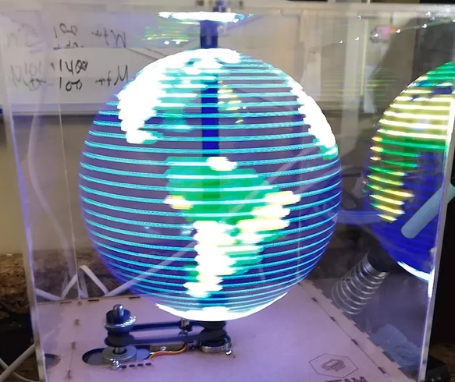

Figure 2: ESP32-based spherical POV display (Welsh, 2020)
The literature supports the design decision to pursue a swept-surface POV fan over volumetric or holographic alternatives. The computation demands, narrow viewing angle, and coherent-optics requirements of holographic systems (Huang et al., 2026) are incompatible with the budget, whereas the documented hardware economy of POV fan displays (Saleh et al., 2018) aligns directly with that constraint.

The POV Effect
The POV effect exploits the temporal integration of the human visual system to render a moving LED array as a continuous image. The governing parameter is the critical flicker fusion (CFF) threshold. This is the frequency above which an intermittent stimulus is perceived as steady, which determines the minimum effective refresh rate and the minimum rotational speed required for a stable, flicker-free display.
POV is the brief retention of a visual stimulus after it is removed (Paul et al., 2013). Coltheart (1980) distinguishes several phenomena conflated under this label, identifying visible persistence, rather than neural persistence, as the mechanism that fuses intermittent stimuli into continuous perception. Mishra et al. (2021) attribute the integration of a spinning LED row into a 2D image to iconic memory, noting that the eye does not sample the world in discrete frames. Paul et al. (2013) report the widely cited lower bound of approximately 16 frames per second, below which distinct flashes are perceived.
Modern CFF measurements place the threshold above the 16 Hz lower bound. Haarlem et al. (2024) measured a mean CFF of approximately 50 Hz across participants, with values ranging from 34 Hz to 65 Hz, and reported that roughly 80% of the variance arose from stable inter-individual differences. CFF also rises with luminance, meaning a brighter display must refresh faster to appear steady (Haarlem et al., 2024). Comfortable flicker-free perception for most viewers therefore requires an effective refresh rate between 34 Hz and 50 Hz.
Empirical POV studies confirm these thresholds and link them to rotational speed. Lee et al. (2022) found that a single-arm propeller display required approximately 950 rpm for image onset and 1 030 rpm for a flicker-free result, corresponding to 17 refreshes per second. A dual-arm rotor centred on its axis paints the full image twice per revolution, halving the rotational speed required to achieve the same effective refresh rate (Lee et al., 2022). This establishes the direct dependence of perceived stability on both rotational speed and arm count.
These thresholds inform the speed and refresh specifications. A dual-arm rotor at 700 rpm refreshes each angular position twice per revolution, yielding an effective refresh rate of approximately 24 Hz. This exceeds both the 16 Hz perception lower bound (Paul et al., 2013) and the empirically observed single-arm flicker threshold of 17 Hz (Lee et al., 2022). It falls below the 34–50 Hz range measured by Haarlem et al. (2024). However, those measurements used square-wave flicker stimuli, whereas a rotating LED arm produces a swept stimulus for which Lee et al. (2022) observed flicker-free perception at 17 Hz. The 24 Hz target is therefore set against the rotating-display evidence, with 16 Hz as the hard lower bound, and image stability is verified experimentally during testing.

Applications and Market Context
POV fan displays have documented applications in education, advertising, and public information.
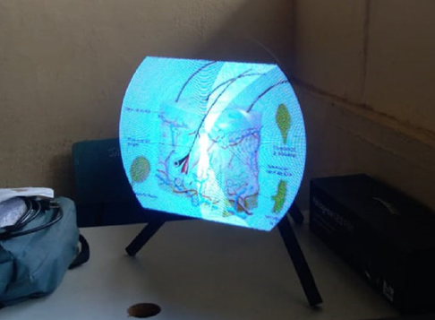

Figure 3: Hologram-like fan used in the classroom (Ortega et al., 2020)
Studies on educational deployment report measurable learning benefits over conventional media. Fokides et al. (2023) found that 174 primary-school pupils using pseudo-holographic 3D LED fan displays outperformed peers using computer-rendered 3D models, with higher engagement and motivation. Ortega et al. (2020) similarly identified the technology as a low-cost resource for improving student motivation in secondary settings where specialist hardware is unavailable. Both studies identify affordability and ease of classroom integration as key adoption factors (Ortega et al., 2020; Fokides et al., 2023).
Commercial and public-space applications constitute the primary deployment context for POV fan displays. Priya et al. (2020) identify advertising signage in shopping malls, airports, and exhibitions as principal domains, noting demand for glasses-free augmented-reality effects. Huang et al. (2026) similarly list education and entertainment as key drivers of three-dimensional display development.

Power Delivery and Dynamic Rotor Balancing
Delivering power to a rotating LED arm and maintaining dynamic balance are tightly coupled challenges: any mass added to address the first directly affects the second. Power can reach the rotating interface via sliding contacts, inductive transfer, or on-board energy storage. Each with distinct penalties in friction, efficiency, complexity, and added rotating mass.
Self-contained rotor power eliminates sliding contacts but adds mass that must be accommodated in the balancing problem. Lammers et al. (2016) show that additive manufacturing enables rotors with deliberately low moment of inertia and reduced mass, limiting both motor loading and imbalance-force magnitude when energy storage is carried on the rotating assembly. On-board cells avoid the wear, electrical noise, and limited life of sliding contacts, at the cost of finite run time and the requirement for symmetric mass placement.
Contactless and slip-based alternatives each introduce characteristic disadvantages. Cheng et al. (2018) demonstrate a regenerative configuration in which an internal motor is reversed to self-supply DC power to the rotating LED circuit, eliminating external wiring and sliding contacts. However, air-gap variation and back-EMF ripple introduce vibration and electrical noise. Slip rings provide continuous current transfer but suffer wear and contact noise, while inductive coupling removes mechanical contact at the expense of transfer efficiency and added coil mass.
The reviewed sources collectively establish the power-delivery and balancing requirements. The low-inertia additively manufactured structures demonstrated by Lammers et al. (2016) mitigate the mass penalty of on-board cells, addressing the requirement to deliver power without physically restricting rotation.

Embedded Systems and Motor Control
POV displays require two timing-critical tasks: precise motor-speed regulation and synchronisation of LED column output to rotor angle. The rotor-position sensing method determines angular accuracy. The motor-control method determines speed stability. This section reviews dual-core embedded architectures, Hall-effect position sensing and BLDC motor control.
Dual-core microcontrollers allow motor control and LED output to run as parallel tasks, which is the principal advantage for POV driving. For example, the ESP32 provides two 32-bit processor cores operating at up to 240 MHz under a real-time operating system, allowing time-critical tasks to be pinned to separate cores so that wireless communication and system services can be done in parallel (Espressif Systems, 2023). Macheso et al. (2021) demonstrate that the same class of device can concurrently host an asynchronous network service while servicing sensor and timing tasks, confirming the feasibility of combining communication and real-time duties on a single low-cost module. In contrast, single-core POV implementations relied on a single processor to interleave all tasks, which constrained timing headroom (Saleh et al., 2018).
Rotor-position sensing in POV displays is commonly accomplished with a Hall-effect sensor that detects a fixed magnet once per revolution to establish an angular reference. The controller then interpolates column timing from the sensor. This approach is adopted consistently across the surveyed implementations (Lee et al., 2022; Saleh et al., 2018). A single index pulse fixes the once-per-revolution datum, while finer angular resolution is obtained by timing interpolation between pulses (Saleh et al., 2018; Lee et al., 2022). The choice therefore trades sensor cost and complexity against achievable angular resolution.
Brushless direct-current motor control provides the stable, efficient speed regulation required to hold a constant image geometry. Kumar et al. (2024) implement field-oriented control (FOC) for a BLDC motor, transforming the three-phase stator currents into a rotating reference frame so that torque and flux are controlled independently. This yields accurate closed-loop speed regulation with low torque ripple.

Software Architecture and Image Processing
The software stack must deliver a user interface, transform raster images into a polar column map, buffer animation frames, and synchronise multiple units over a wireless link. This section reviews embedded web-server hosting, the polar transformation and its interpolation, animation buffering, and the wireless synchronisation protocol for multi-unit coordination.
A resource-constrained microcontroller can host a web server, removing the need for installed client software. Macheso et al. (2021) demonstrated a standalone asynchronous web server on an ESP32 that served real-time data to clients, confirming that a low-cost embedded device can act as both access point and web host. Any browser-equipped device can connect without client-side installation (Macheso et al., 2021; Espressif Systems, 2023).
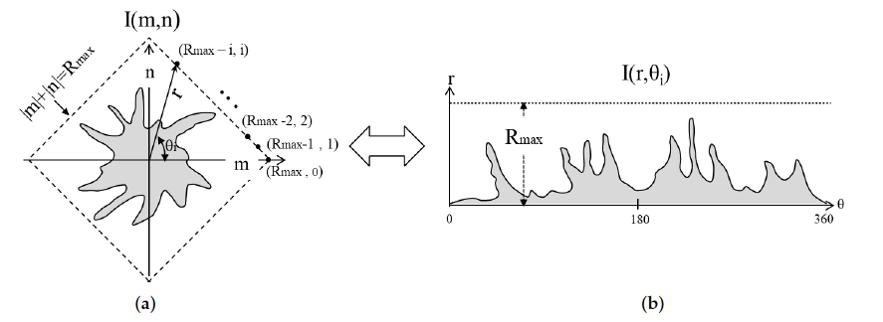
The LED column map requires a Cartesian-to-polar transformation: each pixel at (x, y) maps to a radius and angle via the standard polar relations. Because the polar sampling grid does not align with the Cartesian pixel grid, the transform is non-uniform and requires interpolation to avoid artefacts (Park et al., 2007). Matungka et al. (2009) show that the conventional log-polar transform under-samples the periphery and over-samples the centre and propose an adaptive transform that samples evenly. Park et al. (2007) demonstrate near-lossless interconversion through optimally fitted expansions, and Lee et al. (2024) reduce directional sampling variance with a discrete polar scheme.
Figure 4: Image conversion between Cartesian and polar coordinates (Lee et al., 2024). (a) Image in the discrete Cartesian coordinate. (b) Image in the discrete polar coordinate.

Interpolation strategy trades image quality against computational cost. Nearest-neighbour interpolation is the least demanding but produces aliasing; bilinear interpolation yields smoother results at higher cost; angular under-sampling at large radius is the principal error source in polar mapping (Matungka et al., 2009). Alakuijala et al. (1992) state that explicit coordinate-system transformation simplifies subsequent processing, supporting a pre-computed lookup approach. A fixed pixel-to-LED mapping table for a given geometry allows the transformation to be computed once, reducing rotation-time processing to lightweight buffer playback.

System Specifications
This section presents the system specifications for the 3D hologram-like RGB LED fan display unit. These specifications are derived from the literature review and the broader project context; they define the stakeholder and engineering requirements that the system must satisfy. The primary stakeholders are the staff and students of the Department of Mechanical and Mechatronic Engineering at Stellenbosch University, who represent the intended users and beneficiaries of the system. The specifications outlined in this section establish the basis against which subsequent design concepts and the final system will be evaluated.

Stakeholder Requirements
The stakeholder requirements can be found in Table 1 and are ranked according to their relative importance to the project. Safety is regarded as the highest priority, given the risks associated with a high-speed rotating display. Thereafter, requirements relating to display quality and functionality are prioritised, as these define the core performance of the system.
Table 1: Stakeholder Requirements
SR | Requirement | Description | Ranking
SR01 | Physical Guarding | The rotating assembly must be enclosed to prevent accidental contact with spinning blades during operation. | I
SR02 | Safe Power Management | The unit must not expose live conductors. Power supply must include overload protection. | II
SR03 | Static and Dynamic Content | The system must be capable of displaying both static images and simple animated/dynamic scenes. | III
SR04 | Automatic Shutdown | The system must automatically stop the motor if an error such as high temperature or high speed is detected. | IV

SR | Requirement | Description | Ranking
SR05 | Full Colour Rendering | The display must render full RGB colour images using addressable LEDs. | V
SR06 | Within Budget | Total costs must not exceed the allocated budget of R5000. | VI
SR07 | Additive Manufacturing | The design must incorporate 3D-printed components. | VII
SR08 | Modular and Maintainable | The design must be modular to support multi-fan expansion and future academic modifications. | VIII
SR09 | Portable and Self-contained | The unit must be transportable by a single person and operable from a standard wall outlet. | IX
SR10 | Custom Content Upload | The user interface must allow users to upload custom content for display. | X
SR11 | Fan Operation Control | The user interface must provide controls to start, stop and adjust the operating parameters remotely. | XI
SR12 | Device Independent Access | The user interface must be accessible from standard electronic devices without requiring software installation. | XII
SR13 | Flicker-free Perception | The rotational speed must be sufficient to produce a stable, flicker-free image. | XIII
SR14 | Low Noise Operation | The unit must comply with Western Cape noise regulations. | XIV
SR15 | Environmental Consideration | Minimise environmental impact through the selection of recyclable or sustainably sourced materials where possible. | XV

Functional Requirements
The functional requirements presented in this section define the functions the system must perform in order to satisfy the stakeholder requirements outlined in the previous section. Each functional requirement is mapped to the corresponding stakeholder requirement from which it is derived. The complete set of functional requirements is presented in Table 2.
Table 2: Functional Requirements
FR | Function | Description | Derived From
FR01 | Guard the rotating assembly | Physically enclose the system to prevent contact during operation. | SR01
FR02 | Detect faults and shut down | Detect electrical or mechanical fault conditions and automatically bring the system to a safe stopped state. | SR02  SR04
FR03 | Deliver power to the rotor | Deliver power to the electronics mounted on the rotating assembly. | SR02
FR04 | Rotate the LED arm | Rotate the LED arm to produce an image through the POV effect. | SR13
FR05 | Provide a user interface | Provide a user interface accessible from any common device without requiring software installation. | SR10  SR12
FR06 | Provide remote fan control | Allow the user to start, stop and adjust operating parameters of the fan display remotely. | SR11
FR07 | Accept user content uploads | Accept and process user-uploaded images and animations via the user interface. | SR10
FR08 | Convert images to polar format | Convert the image into a polar LED column map that can be outputted in synchronisation with the rotor angular position to produce the display image. | SR10  SR03

FR | Function | Description | Derived From
FR09 | Drive addressable RGB LEDs | Drive a strip of individually addressable full-colour RGB LEDs mounted on the rotating arm. | SR05
FR10 | Sense rotor angular position | Sense the angular position of the rotor in real time. | SR03
FR11 | Incorporate 3D-printed parts | Incorporate additively manufactured components into the system design. | SR07
FR12 | Use custom firmware and software | Execute display driving, position handling and motor control functions through custom-developed software with no pre-built libraries. | SR08  SR03
FR13 | Play back animations | Support frame-based animation playback on the display to produce moving dynamic scenes. | SR03  SR13
FR14 | Be portable and self-contained | Be transportable and operable by a single person from a standard mains wall outlet. | SR09
FR15 | Operate at low noise levels | Minimise noise generated by the motor and rotating assembly to comply with the Western Cape Noise Regulations. | SR14
FR16 | Synchronise multiple display units | Coordinate the display output of two or more fan units over a wireless link to render a composite image. | SR03  SR08

Technical Performance Measures
The technical performance measures presented in this section define the measurable targets the system must achieve in order to satisfy the stakeholder and functional requirements outlined above. Each performance measure provides a quantifiable criterion against which the final design can be evaluated. The derivation of these targets is detailed in Appendix C.
Table 3: Technical Performance Measures
TPM | Description | Target | Range | Unit | Derived From
TPM01 | Rotor operating speed | 700 | ≥ 600 | RPM | FR04
TPM02 | Total system cost | 4500 | ≤ 5000 | ZAR | All
TPM03 | Unit total mass | 5 | ≤ 10 | kg | FR14
TPM04 | Swept display diameter | 400 | ≥ 300 | mm | FR04
TPM05 | Colour depth per LED | 8 | ≥ 8 | bits per channel | FR09
TPM06 | Number of LEDs per arm | 32 | ≥ 25 | - | FR09
TPM07 | Number of discrete LED positions | 360 | ≥ 180 | columns per revolution | FR08
TPM08 | Number of synchronised fan display units | 2 | ≥ 2 | - | FR16
TPM09 | Display refresh rate | 24 | ≥ 16 | Hz | FR04
TPM10 | Fan display noise level | 40 | ≤ 50 | dBA | FR15
TPM11 | Supports JPEG, PNG and GIF inputs | Yes | Yes/No | - | FR07
TPM12 | Animation frame rate | 12 | ≥ 10 | fps | FR13
TPM13 | Mains voltage supply compatibility in South Africa | 230 | = 230 | V | FR14
TPM14 | Mains frequency supply compatibility in South Africa | 50 | = 50 | Hz | FR14

Concept Design
The fan display unit is a mechatronic system in which hardware and electronic subsystems are interdependent. The system consists of a motor-driven rotating arm fitted with an addressable LED strip, which exploits the POV effect to render a stable image in free space. Image fidelity depends on both the mechanical precision of the rotating assembly and the electronic synchronisation of LED output to rotor angular position. These two factors impose distinct design constraints and possible solutions. Therefore, concept generation is split into hardware and electronic concepts, discussed in Sections 4.1 and 4.2 respectively.

Hardware Concept Design
The hardware design must satisfy three main requirements: structural support and mounting of the rotating assembly, safe enclosure of the rotating arm, and mass-balanced placement of electrical components to limit vibration. Enclosing the rotating assembly with a physical safety guard introduces its own design space. The guard must prevent accidental contact with the spinning arm while maintaining optical access to the display image. AM is used extensively throughout, requiring printed parts to withstand the centrifugal, bending, and vibratory loads of high-speed rotation. Three concepts, each resolving these requirements differently, are presented below.

Hardware Concept 1: Linear Rail Mounted Assembly
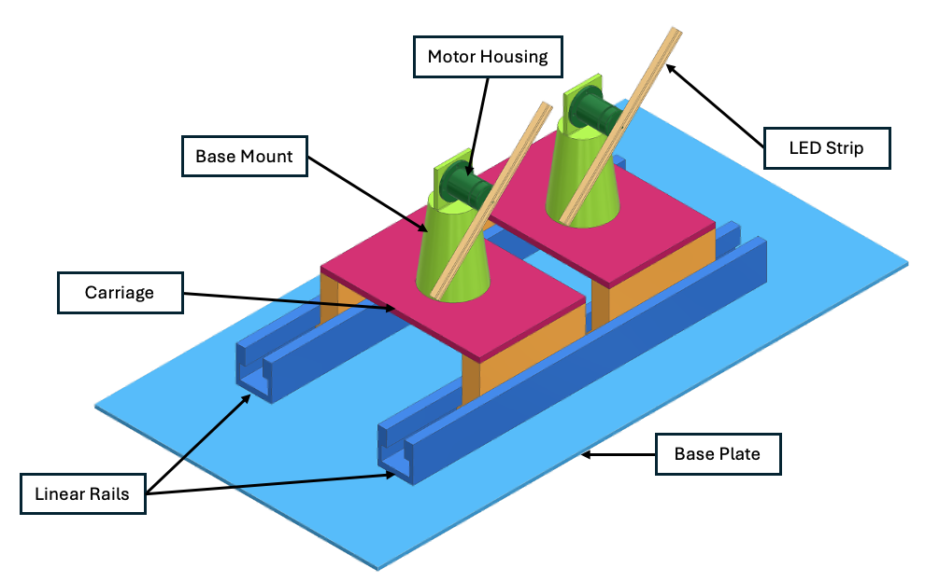

Figure 5: Linear rail CAD model
In this concept, the fan motor assembly is mounted on a carriage that translates along a pair of parallel extruded rails fixed to the base structure, as shown in Figure 5. The motor and rotating arm sit on a 3D-printed platform bridging the two rails, driven along the rail axis by a dedicated actuator, giving the system a second degree of freedom.
The primary advantage is scalability. Translating the fan assembly laterally during operation extends the effective display width beyond the swept diameter of a single arm, enabling a wider composite image. The rail system also supports a multi-fan arrangement, with additional assemblies mounted on the same rail and operated in coordination. The entire assembly is contained within a transparent box guard, preventing accidental contact with the spinning arms while leaving the arms free to overlap within the enclosed volume to form the composite image. Since the rotating arms are individually unguarded, their swept areas can overlap, allowing the individual images to merge into a single composite display.
This functionality comes at a cost. The translation axis requires its own actuator, motor driver, and control logic. This increases the component count, complexity and cost, with direct implications for budget compliance. The carriage must also support the combined mass of the motor assembly, electronics and housing, raising the structural load on the base frame and the inertial demand on the actuator. Total system mass is therefore higher than a fixed-base configuration, reducing portability.
The concept provides only a single, fixed viewing angle, as the rail axis is horizontal and the display face is fixed relative to the carriage, with no provision for elevation or reorientation. Combined with the larger structural footprint of the rail system, this limits both deployment flexibility and portability, as the assembled unit is less compact and harder to transport as a single package.

Hardware Concept 2: Trunnion Mount Assembly
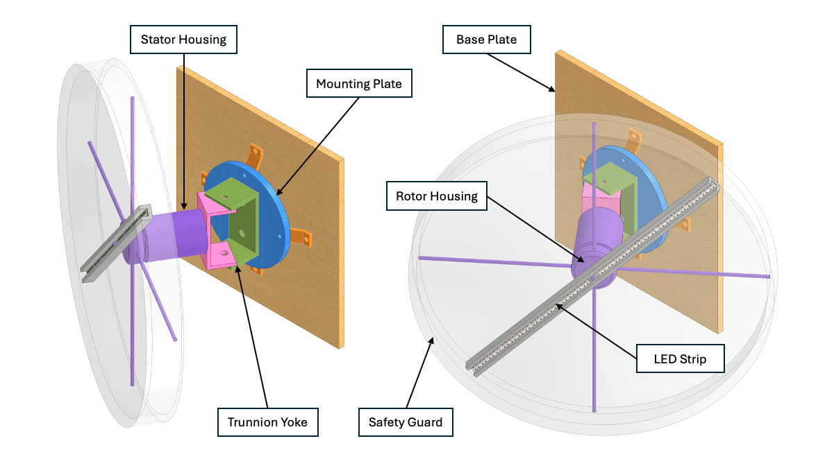

Figure 6: Trunnion style bracket CAD model
Concept 2 uses a trunnion style yoke bracket to mount the motor assembly, as shown in Figure 6. The yoke pivots about a horizontal axis, allowing the fan assembly to rotate through 180°. This enables the display to be oriented at any angle between vertically upright and fully reclined. This single feature enables wall-mounted or ground-mounted deployment without hardware modification, addressing the portability and flexibility requirements beyond what a fixed-base concept offers.
A notable feature is the safety guard, integrated directly around the rotating hub rather than as a separate enclosing structure. Mounted concentrically with the swept display diameter, the guard contains the rotating arm within the plane of rotation. This tight integration reduces the overall structural envelope and avoids the need for a large external housing, benefiting portability and visual cleanliness.
Multiple fan units can be mounted adjacently, with each trunnion assembly fixed to a common wall panel or base plate, enabling coordinated multi-fan synchronisation for a wider composite display. Since each fan assembly is independently supported by its own yoke, no additional actuation is required for the multi-fan arrangement, unlike Concept 1. However, the physical guarding prevents the fan blades from overlapping to form a single unified image.
The primary structural concern is the bending moment imposed on the trunnion yoke bracket. The combined mass of the motor, rotating arm, electronics, and guard is cantilevered off the yoke pivot point, generating a significant bending load at the yoke arms and their interface with the mounting plate. This load is amplified by dynamic forces from rotor imbalance and vibration transmitted through the motor shaft. Given the anisotropic mechanical properties of FDM parts, AM is unsuitable for this component under sustained bending loads. The yoke bracket therefore requires custom manufacturing from steel, which increases material and fabrication costs relative to a 3D-printed equivalent.

Hardware Concept 3: Fully Enclosed Assembly
In this concept, the system is housed in a hinged, briefcase-style enclosure divided into two halves, as shown in Figure 7. The lower half is a fixed compartment housing the power supply, control electronics, and wiring. The upper half contains the rotating fan assembly, with the motor mounted to the rear panel of the lid and the arm sweeping within the enclosed face. A transparent panel on this face acts as the safety guard, enclosing the rotating arm while keeping the display visible.
The hinge serves a dual purpose: it is the structural joint between the two halves, and its angle can be adjusted to reorient the display face relative to the base, giving different viewing angles without additional mounting hardware.
This provides angular flexibility similar to the trunnion pivot of Concept 2, though limited to the hinge axis and the range of angles at which the open enclosure remains stable.
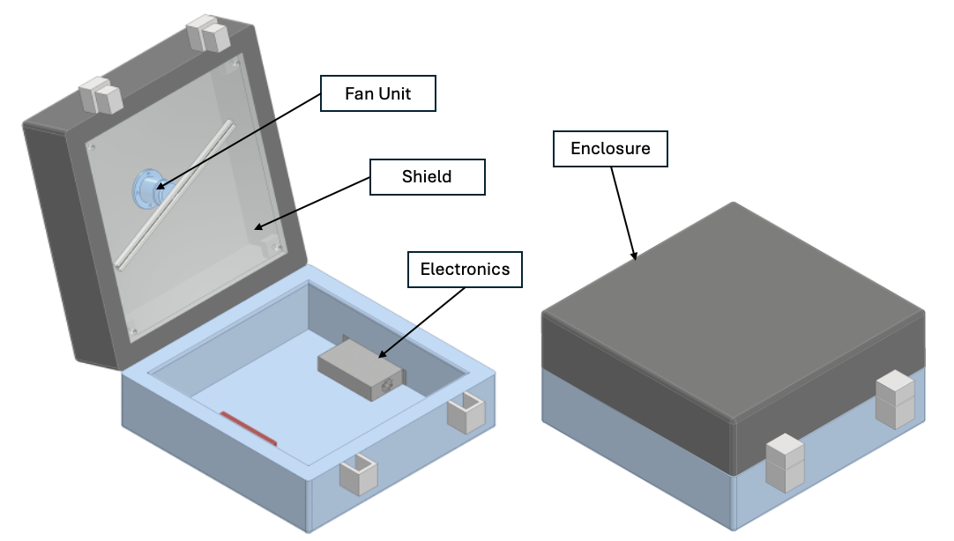

Figure 7: Fully enclosed concept CAD model

This configuration offers the greatest portability of the three concepts. All system components are integrated within a single enclosure that can be latched shut, carried, and deployed by one person without tools or supplementary infrastructure. The lower half also provides a stable ground contact surface, and the enclosed design protects internal components during transport.
The principal limitation is that the self-contained enclosure precludes multi-fan synchronised operation. Once enclosed, the unit functions as an independent display module with no means of mechanically coupling or coordinating with adjacent units to form a wider composite image. The fixed envelope also constrains internal layout, potentially limiting power supply size or cable routing between compartments.

Electronic Concept Design
The electronic design must satisfy four requirements: accurate sensing of rotor angular position, a power supply subsystem serving multiple voltage rails from a single mains input, reliable transfer of power across the rotating interface, and balanced allocation of components between the stator and rotor side to limit rotor imbalance. These considerations are differentiated not by physical configuration, as with the hardware concepts, but by the underlying operating principles and integration strategies available for each subsystem. Three concepts, each addressing one of these considerations, are presented below.

Electronic Concept 1: Decoupled, Battery Powered System
In this concept, the stationary and rotating subsystems are fully decoupled, with no electrical connection across the rotating interface during operation. The stationary side houses the mains power supply, motor and motor driver circuit. Speed control is open-loop as there is no feedback path from the rotor. A potentiometer on the stationary side sets an approximate motor speed by adjusting the drive signal to the motor driver.
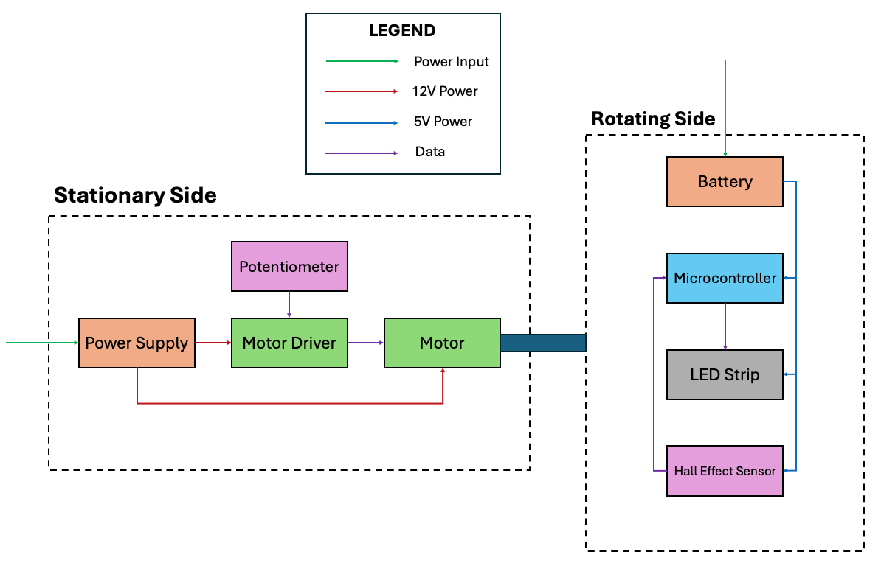

Figure 8: Decoupled, battery powered flow diagram concept

Angular position sensing uses a Hall effect sensor on the rotating frame, triggered by a reference magnet fixed to the stationary assembly. This produces one pulse per revolution, which the microcontroller uses to establish rotational period and synchronise LED column timing. The rotating side is powered entirely by an onboard battery, supplying the LED strip at the required voltage and current independently of the stationary electronics. This removes any need for a slip ring, wireless power transmitter, or other cross-interface power delivery mechanism. This eliminates the associated complexity, contact wear, and electromagnetic noise risk. Between operating sessions, the battery is recharged via a charging cable connected directly to the rotor.
The primary advantage of this concept is electrical simplicity at the rotating interface. As there is no electrical connection across the rotating interface, there is no wear, no contact resistance, and no speed limit imposed by the power transfer method. However, the battery adds mass to the rotating arm, requiring careful placement to keep the rotor balanced. The capacity must also sustain peak LED current draw for a full operating session without affecting LED brightness or microcontroller stability.

Electronic Concept 2: Slip Ring System
Concept 2 uses a slip ring to transfer power and data across the rotating interface. A slip ring is a mechanical assembly of conductive rings and brushes that maintains continuous electrical contact between the stationary and rotating frames irrespective of rotational speed. The stationary side houses the mains power supply, motor and motor driver. The Hall effect sensor is mounted in the same manner as Concept 1.
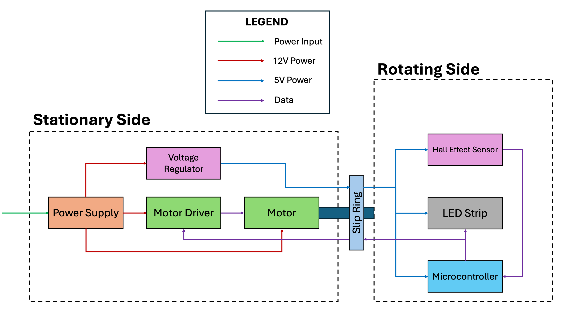

Figure 9: Slip ring flow diagram concept

The voltage regulator conditions the incoming power supply before it is passed through the slip ring to the rotating side, which houses the LED strip and microcontroller. The microcontroller, in turn, sends a control signal back through the slip ring to the stationary motor driver, closing the control loop for motor speed regulation from the rotor side.
This architecture is the most conventional approach to cross-interface power and data delivery in rotating electrical systems. The main advantage is continuous, real-time data streaming, limited only by the electrical bandwidth of the slip ring contacts. However, slip rings carry limitations. Brush-to-ring contact is a wear surface that degrades over time, generating conductive debris that causes intermittent contact resistance and electrical noise on the data signal. At higher rotational speeds, brush bounce and increased contact resistance become more pronounced, which can corrupt the LED data stream and produce visible display artefacts. The slip ring introduces additional cost and periodic maintenance, and its use is contingent on sourcing a slip ring in South Africa that is suitably sized and rated for the target operating speed of 700 rpm.

Electronic Concept 3: Wireless Power System
Concept 3 uses an inductive wireless power transmitter and receiver pair to transfer power across the rotating interface. The transmitter coil is fixed on the stationary frame and the receiver coil is mounted on the rotating assembly, allowing continuous power delivery across an air gap without any physical contact. The stator side microcontroller controls the motor through the motor driver to provide closed-loop control. Angular position sensing is performed by a rotary encoder integrated with the motor shaft rather than a Hall effect sensor, providing higher angular resolution and a continuous position signal rather than a single pulse per revolution.
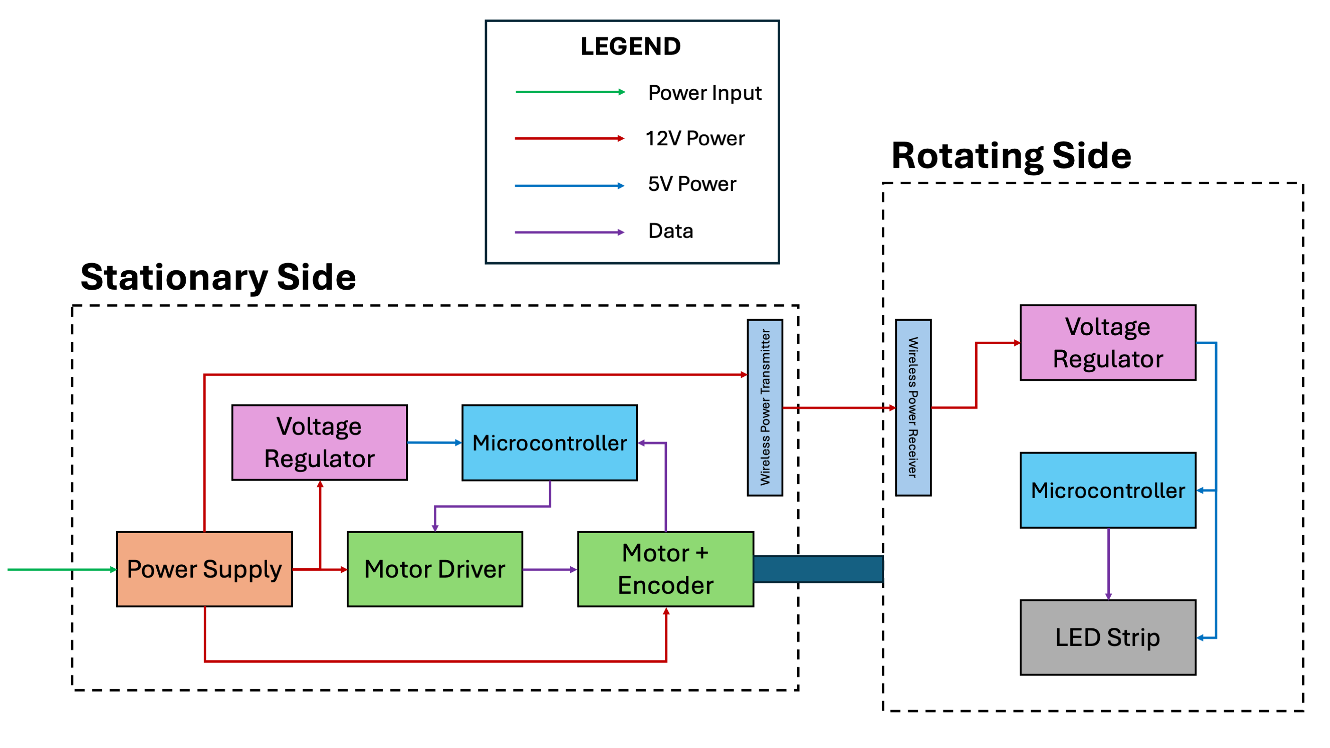

Figure 10: Wireless power flow diagram concept

The rotating side is electronically self-contained. A voltage regulator conditions the wirelessly received power to the voltage required by the onboard components. This avoids the need to transmit a low-voltage, high-current signal through the wireless power transmitter. A second microcontroller, mounted on the rotating arm, handles all display functions which includes image data storage, LED timing synchronisation and addressable LED driving. As there is no data transfer over the rotating interface, display data must be pre-loaded onto the rotor microcontroller before operation, and any image updates require the system to stop.
The main advantage of this concept is the elimination of sliding electrical contacts. Wireless power transfer removes the wear and noise associated with the slip ring in Concept 2. The use of a motor encoder rather than a Hall effect sensor also provides finer angular position resolution, supporting synchronisation accuracy. However, inductive power transfer efficiency is sensitive to coil alignment, air gap distance and the load demand. The power available at the receiver is lower than the transmitted power due to coupling losses.

Concept Evaluation
All concepts presented in Sections 4.1 and 4.2 were evaluated as technically feasible, each capable of meeting the fundamental functional requirements defined in Section 3.2. As the concepts are currently broadly defined and not yet sufficiently detailed for a quantitative comparison against the TPMs, a qualitative evaluation is used to reduce the candidates to a single preferred solution for each of the hardware and electronic subsystems. The evaluation is conducted using a weighted Pugh decision matrix, in which concepts are scored relative to a reference datum across a set of evaluation criteria derived from the specifications established in Section 3.

Hardware Concept Evaluation
This section compares the concepts in terms of the following Evaluation Criteria (EC) for the hardware concepts:
1. Safety and Stability
Covers how well the concept physically guards the rotating assembly and remains stable at high RPM.
2. Cost and Component Availability
Covers both unit price and local sourcing in South Africa. If the components are unavailable, the testing and optimisation phase will be affected.
3. Modularity
The unit must support multi-fan expansion.
4. Portability
The unit must be transportable by a single person.
Manufacturability and use of AM is excluded as a distinct evaluation criterion, as additive manufacturing is applied comparably across all three concepts and does not differentiate between them at the concept level. Concept 2 requires a steel bracket; however, this cost would fall under the material costs section.
EC01 and EC02 rate Concepts 1 and 3 identically and therefore discriminate only against the datum; the selection between Concepts 1 and 3 is decided by EC03 and EC04, of which modularity (EC03) carries the higher weight consistent with SR08.

Table 4: Decision Matrix for Hardware Concepts
Criterion |  |  | Concept 1: Linear Rail Mount |  | Concept 2: Trunnion Mount |  | Concept 3: Enclosed System
# | Description | Weight | Rating | Motivation | Datum | Motivation | Rating | Motivation
EC01 | Safety and Stability | 4 | +1 | The entire system can be enclosed, and the loads are evenly distributed. |  | - | +1 | The rotating assembly is fully enclosed which reduces contact risk.
EC02 | Cost and Component Availability | 3 | -1 | The linear rail adds an actuator and control system. |  | - | -1 | The enclosure introduces higher material costs.
EC03 | Modularity | 2 | +1 | Multiple displays can be overlapped and synchronised. |  | - | -1 | The enclosure prevents multiple synchronised displays.
EC04 | Portability | 1 | -1 | The system has a wide footprint due to the linear rail. |  | - | +1 | The briefcase-style enclosure provides the best portability.
Number of plus ratings |  |  | 2 |  |  |  | 2
Number of minus ratings |  |  | 2 |  |  |  | 2
Overall total |  |  | 0 |  |  |  | 0
Weighted total |  |  | 2 |  | 0 |  | 0

Tables 4 and 5 present a systematic comparison of the concepts. The ECs are listed in the left-hand column, followed by a weighting of their relative importance on a scale of 1 to 4, where 4 represents the most important criterion. For rating the concepts, the other concepts were compared with the concept marked DATUM (Concept 2). A (+1) was awarded if the other concept is stronger, (-1) if the other concept is weaker or (0) if the concepts are equivalent. A motivation is given in the table for the ratings of the concepts, and only if the rating is (+1) or (-1). Weightings were ranked according to the SRs in Section 3.1, where safety (SR01) receives the highest weight, followed by cost (SR06), modularity (SR08) and portability (SR09).

Electronic Concept Evaluation
This section compares the concepts in terms of the following ECs for the electronic concepts:
1. Power Delivery Reliability
Covers how reliably and safely the concept can continuously deliver at least 5V, 2A to the rotor electronics at 700 RPM. Wireless power transmitters are often rated for a lower current load. Moreover, the slip rings available in South Africa are rated for below 300 RPM (MicroRobotics, 2026). The battery eliminates the rotating power interface entirely.
2. Cost and Component Availability
Evaluates if the components can be sourced from local South African suppliers within budget. A concept that avoids imported components such as through-bore slip rings and high-current wireless power modules scored highest.
3. Rotor Balance and Vibration
Evaluates how much mass each concept places on the rotating assembly and the ability to symmetrically distribute the rotor mass. Excess or asymmetric rotor mass directly drives vibration.
4. Position Feedback and Control
Evaluates if the concept provides continuous, real-time rotor position feedback to close the speed and synchronisation control loop. Alternatively, it could rely on open-loop assumptions or non-real-time data transfer.
Static and dynamic scene capability is excluded as a distinct criterion, as image fidelity is a consequence of power delivery reliability rather than an independent differentiator between concepts.

Table 5: Decision Matrix for Electronic Concepts
Criterion |  |  | Concept 1: Decoupled, Battery |  | Concept 2: Slip Ring |  | Concept 3: Wireless Power
# | Description | Weight | Rating | Motivation | Datum | Motivation | Rating | Motivation
EC01 | Power Delivery Reliability | 4 | +1 | The battery provides a continuous output, only limited by its specification. |  | - | -1 | Coil misalignment degrades efficiency and decreases image quality.
EC02 | Cost and Component Availability | 3 | +1 | Correctly rated batteries are readily available in South Africa. |  | - | -1 | Very few wireless coils that can support the voltage and current load. Also includes an extra microcontroller.
EC03 | Rotor Balance and Vibration | 2 | -1 | The battery adds mass to the rotor which could affect balance. |  | - | 0 | -
EC04 | Position Feedback and Control | 1 | -1 | The potentiometer only provides an approximate motor speed. |  | - | +1 | The encoder allows for closed-loop motor control.
Number of plus ratings |  |  | 2 |  |  |  | 1
Number of minus ratings |  |  | 2 |  |  |  | 2
Overall total |  |  | 0 |  |  |  | -1
Weighted total |  |  | 4 |  | 0 |  | -6

Detail Design
Based on the results of Section 5, hardware concept 1 and electronic concept 1 were selected via the Pugh decision matrix for detail design. Where the concept design phase established the functional architecture of each subsystem, the detail design phase refines these into specific components, electrical interfaces, and physical implementations, guided by the system specifications defined during the requirements phase.
Two refinements were made to the selected electronic concept during detail design. First, motor speed regulation was implemented as closed-loop FOC using an integrated encoder on the stationary side, replacing the open-loop potentiometer arrangement. This removes the position-feedback weakness identified in the concept evaluation (EC04) without introducing any connection across the rotating interface. Second, the addition of the linear rail subsystem requires a third microcontroller and wireless coordination via ESP-NOW. This complexity is attributable to the selected hardware concept's translation axis, whose cost implications were accounted for under EC02 of the hardware evaluation.
Component selection is treated as a coupled rather than independent problem, since each component constrains adjacent subsystems through voltage levels, communication protocols, current demand, and physical mass and dimensions. These interdependencies are resolved through iterative cross-subsystem compatibility verification rather than sequential, isolated selection. The following subsections address each subsystem in turn, together forming the integrated system that satisfies the FRs and TPMs defined in the system specifications.

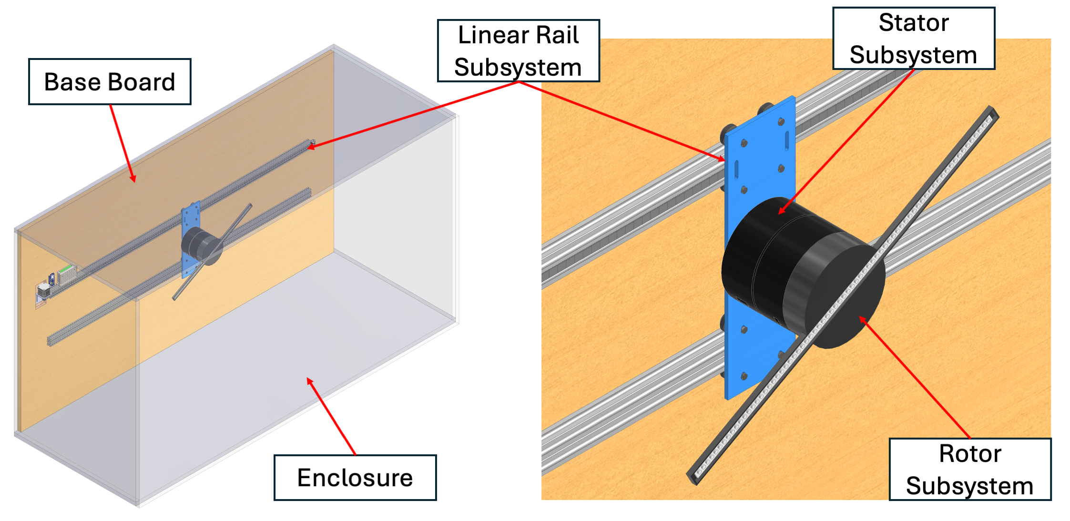
Design Overview
Figure 11: Final system assembly CAD model
The complete assembly is housed within a transparent plastic enclosure. The enclosure protects the system and user while keeping the linear rail, stator and rotor subsystems visible during operation. A horizontally mounted base board provides the structural foundation to which the linear rail assembly is fixed.
The system is separated into three main physical and electrical subsystems, reflecting the hardware and electronic concepts discussed in Sections 4 and 5. A single fan unit is detailed here; the ESP-NOW control architecture and modular stator/rotor design support the addition of synchronised units without modification, addressing SR08.
The linear rail subsystem translates the entire fan assembly laterally along the base board. The stator subsystem is carried by the linear rail, and houses the motor and control electronics. The rotor subsystem is driven by the stator, and contains the battery-powered display electronics.
Each subsystem is controlled by an independent ESP32 microcontroller. The rail and stator microcontrollers are physically separated by the translating carriage. The stator and rotor microcontrollers are separated by the rotating interface. Communication between the microcontrollers is handled wirelessly via ESP-NOW, as they cannot be physically wired to each other. ESP-NOW operates at a default bit rate of 1 Mbps (Espressif, 2026), sufficient for the control and synchronisation traffic between microcontrollers. The rotor is isolated from both the stator and linear rail, in keeping with the decoupled electronic architecture established in Concept 1. All display data and control logic are self-contained on the rotor, and no physical or electrical connection crosses the rotating interface.
Power enters through a single 12 V DC supply at a fixed input on the base board and splits into two paths. The first path feeds the stationary linear rail electronics directly and the other runs via a cable carrier to the barrel jack on the stator body. On the stator, the 12 V rail drives the motor and driver, while a step-down regulator supplies the 5 V logic rail for the microcontroller. The rotor draws no power across the rotating interface as it is powered independently by an onboard LiPo battery charged via a Type-C connector.
The linear rail, stator and rotor subsystems are each detailed in the following subsections, covering component selection, interface design and physical implementation.

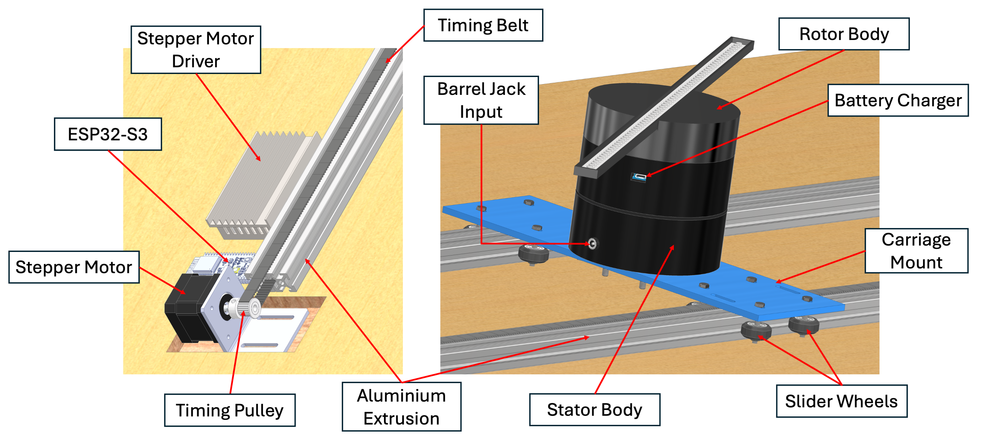
Linear Rail Subsystem
Figure 12: Linear rail subsystem CAD model
The linear rail subsystem implements the lateral degree of freedom identified in the selected hardware concept. It moves the fan assembly along the length of the base board independently of its rotational speed. As seen in Figure 12, the subsystem comprises two parallel aluminium extrusion rails, a 3D-printed carriage supported by V-wheel sliders, a belt-and-pulley drive mechanism on one rail, and the associated stepper motor control electronics.
Two lengths of aluminium extrusion are mounted parallel to one another along the base board, spaced to match the width of the carriage. The aluminium extrusion was selected for its standardised T-slot profile, which allows the carriage wheels, motor mount, and end brackets to be positioned and secured at any point along its length without custom drilling. Only one of the two rails carries the drive mechanism. The second rail is a plain idler rail whose function is to provide a second line of mechanical support for the carriage, preventing it from twisting about the driven rail as it translates. The carriage is a 3D-printed component that bridges both rails. It rides on a set of V-wheels engaged with the V-groove profile of the extrusion, which allows it to slide freely along the rail axis while remaining constrained in the other translational and rotational degrees of freedom. The carriage mount provides the interface to which the stator body is bolted.
Translation is driven by a NEMA17 stepper motor mounted at one end of the driven rail. The stepper motor was selected for its holding torque and open-loop positioning accuracy. The stepper motor drives a timing pulley, which engages a timing belt running the length of the driven rail. The belt is attached to the carriage at a single anchor point, such that rotation of the pulley translates directly into linear motion of the carriage. An idler pulley at the opposite end of the driven rail maintains belt tension. The stepper motor is driven by a TB6600 stepper motor driver, configured at 1/16 micro-stepping, which produces 3200 pulses per revolution. The stepper motor driver converts step and direction signals from the ESP32 microcontroller into the phase currents required to drive the motor windings.
The stepper driver and rail microcontroller are powered directly from the fixed 12 V input. Because the stator translates with the carriage, its supply is carried from the same input along a flexible cable routed through a cable carrier, which maintains slack across the full travel of the carriage without snagging.

Stator Subsystem
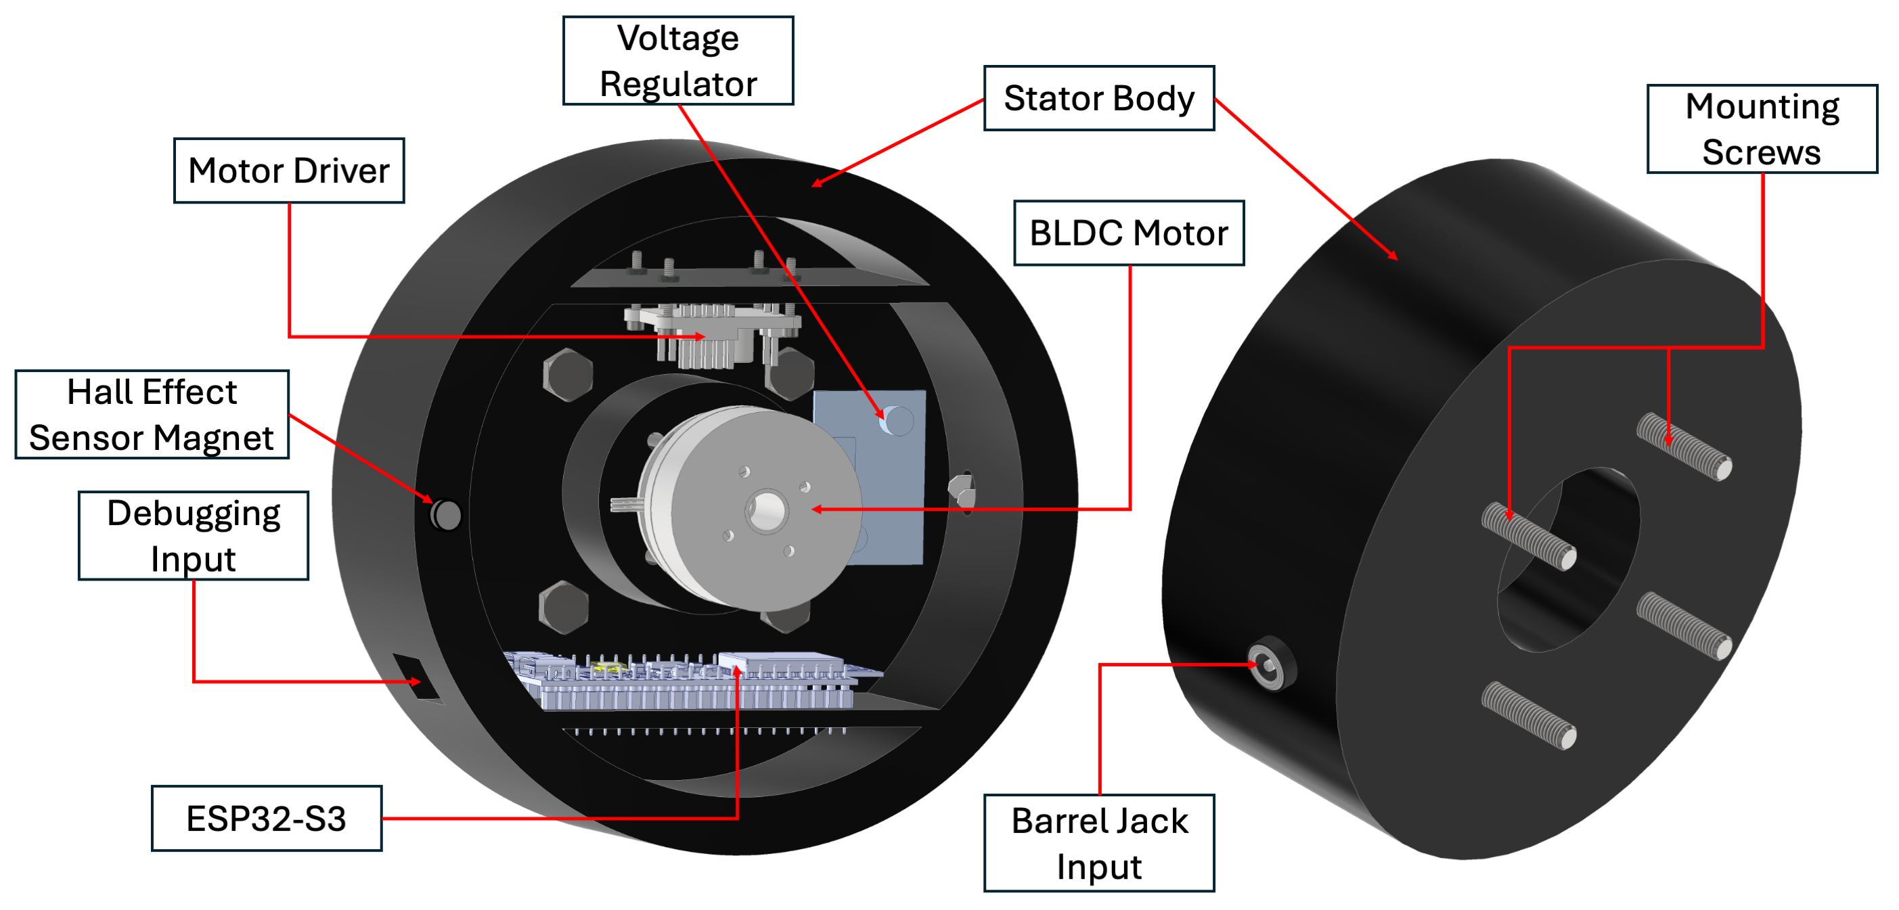
The stator subsystem is the stationary reference for the rotating display and is mounted to the linear rail carriage. It houses the motor and its control electronics and drives the rotor across the rotating interface.
Figure 13: Stator subsystem CAD model
As shown in Figure 13, the subsystem comprises a 3D-printed stator body, a gimbal BLDC motor, a motor driver, a step-down regulator, the stator microcontroller, and the power and debug inputs.
The stator body is fixed to the linear rail carriage by the four mounting screws shown in Figure 13, which fasten it to the carriage mount using bolts. The BLDC motor is seated centrally inside the body and held in place by four internal mounting screws, with its rotating face directed outward through the front of the body. The barrel jack and debugging port are mounted on the body wall: the barrel jack receives the 12 V supply delivered along the flexible cable from the fixed input, while the debugging port provides USB access to the stator microcontroller for flashing and diagnostics without opening the body.
Rotation is produced by a brushless DC motor. This motor was selected because its body itself rotates, with no output shaft: the rotor bolts directly to the four screws on the motor face, removing the need for a separate shaft coupling. The motor-to-rotor interface is detailed in the following subsection. The motor integrates an AS5600 magnetic encoder, which provides absolute rotor angle for closed-loop control.
The motor is driven by a SimpleFOC Mini driver operating directly from the 12 V rail. Using the AS5600 feedback, the driver runs closed-loop field-oriented control, regulating rotor speed against the setpoint issued by the stator microcontroller. Closed-loop operation holds the commanded speed under load, which is required for stable image timing on the rotor. A step-down regulator conditions the same 12 V input to the 5 V logic rail supplying the microcontroller.
Synchronisation with the rotor is established by a reference magnet fixed to the stator body, as shown in Figure 13. A Hall effect sensor on the rotor passes this magnet once per revolution, providing the rotor microcontroller with an angular datum from which LED column timing is referenced. The stator microcontroller communicates with the rail and rotor microcontrollers over ESP-NOW, since no wired connection can cross the translating carriage or the rotating interface.

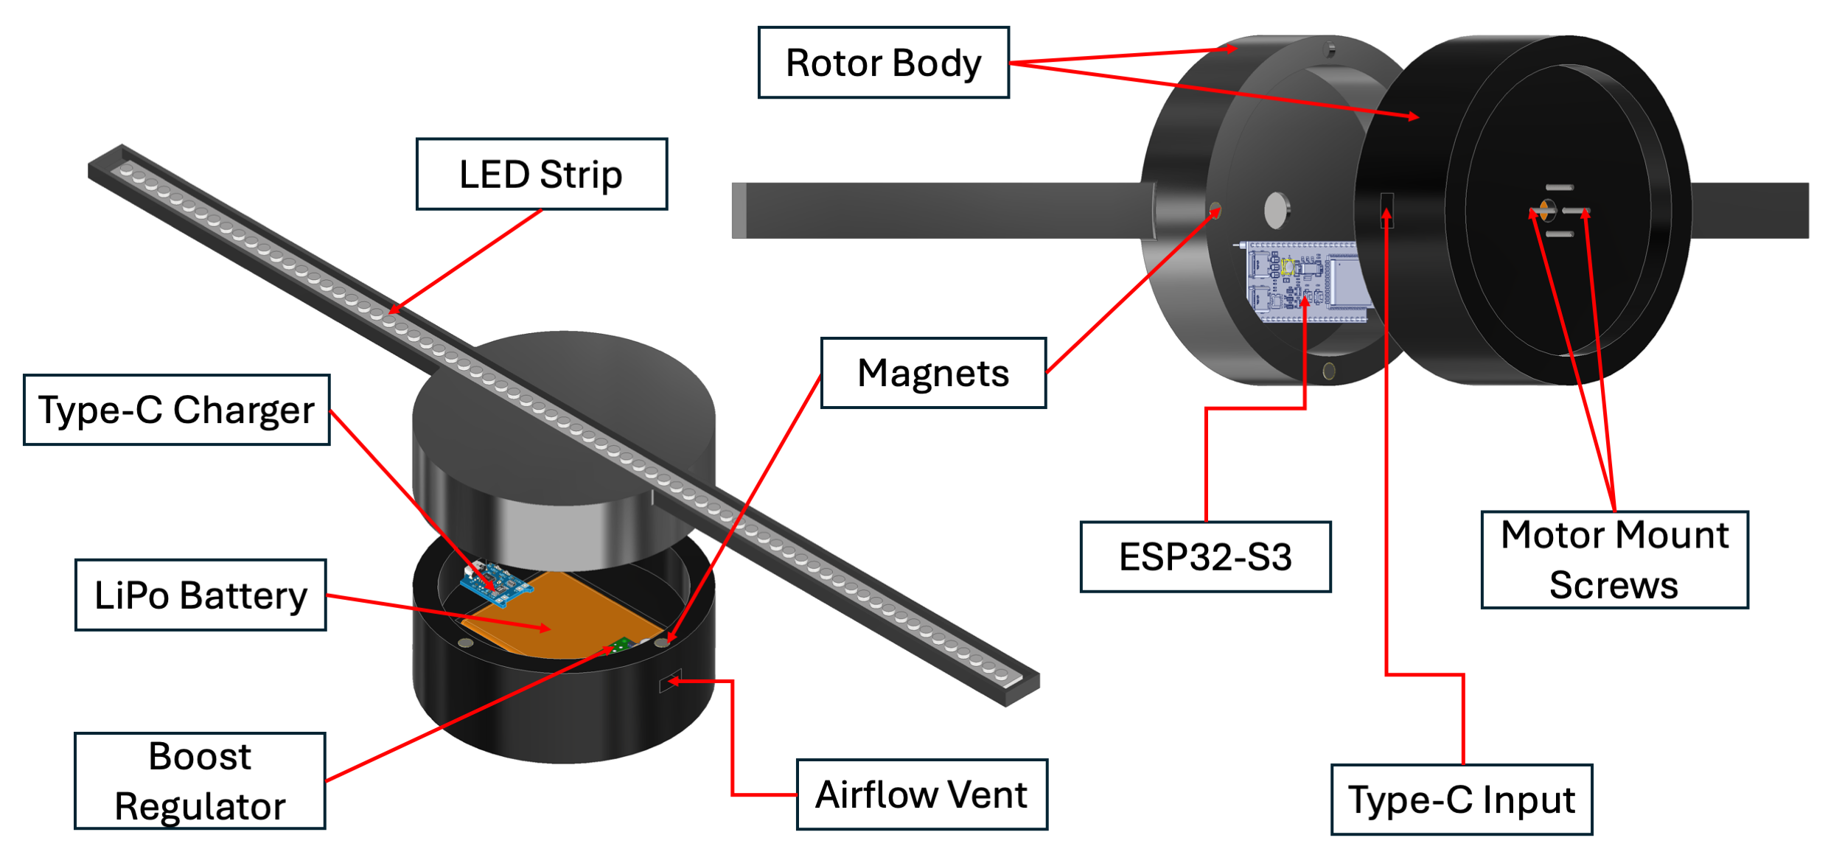
Rotor Subsystem
Figure 14: Rotor subsystem CAD model

The rotor subsystem is the rotating display. It carries the LED strip and all display electronics. Power is provided entirely by an onboard battery. As shown in Figure 14, the rotor body is a two-part 3D-printed assembly that mounts to the motor face and houses the battery, electronics and the LED strip.
The rotor body is split into two halves and joined by embedded magnets, allowing it to be opened by hand for access to the internals without tools or fasteners. One half houses the power electronics while the other contains the display and control electronics. The rotor is fastened to the rotating motor face by four motor mount screws. A Type-C input on the outer body wall connects to the charger, and an airflow vent allows cooling of the internal electronics during rotation.
Rotor balance is managed through battery placement. The LiPo battery is the largest rotating mass, so it is placed into a rectangular pocket at the centre of a circular printed disc, placing its centre of mass on the rotation axis. The surrounding printed material completes the disc so that the mass distribution remains symmetric about the axis, limiting the vibration identified as the main drawback of the battery-powered concept.
The rotor is powered independently by the onboard LiPo battery. The boost regulator steps the battery voltage from 3.7 V to the 5 V required by the LED strip and the microcontroller. Between operating sessions, the battery is recharged through the charger via the Type-C input, with no connection to the stator or rail during operation. This preserves the decoupled architecture established in Concept 1, eliminating the slip ring or wireless power transfer that a powered rotating interface would otherwise require.
The display is produced by an addressable LED strip mounted radially across the rotor body and driven by the ESP32-S3. As the rotor spins, the microcontroller updates the LED columns with the rotor angle to render the image through the POV effect. Angular timing is referenced to the once-per-revolution pulse produced when the Hall effect sensor passes the reference magnet on the stator. The encoder and Hall sensor serve distinct functions, the encoder closes the motor speed loop on the stator side, and the Hall effect sensor provides the rotor microcontroller with its once-per-revolution angular datum.

References
Alakuijala, J. et al. (1992) ‘Image transformation from polar to Cartesian coordinates simplifies the segmentation of brain images.’, 1992 14th Annual International Conference of the IEEE Engineering in Medicine and Biology Society, pp. 1918–1919.
Botes, S. (2025) ‘Design, build and testing of a 3D hologram-like RGB LED fan display’, Department of Mechanical and Mechatronic Engineering.
Chandrika, H.V. et al. (2017) ‘Propeller LED Display’, ATME College of Engineering.
Cheng, J.H. and Lin, H.H. (2018) ‘Design and development of interactive LED display for fan applications’, 2018 IEEE International Conference on Applied System Invention, pp. 393–396.
Coltheart, M. (1980) ‘The persistences of vision’, Philosophical Transactions of the Royal Society of London, 290(1038), pp. 57–69.
Djenouri, D. and Bagaa, M. (2014) ‘Synchronization protocols and implementation issues in wireless sensor networks: A review’, IEEE Systems Journal, 10(2), pp. 617–627.
Doo-Young, G. (2022) ‘Propeller display using POV phenomenon’, The Journal of the Korea institute of electronic communication sciences, 17(6), pp. 1181–1186.
Espressif Systems (2023) ESP32 series datasheet. Espressif Systems. Available at: https://www.espressif.com/sites/default/files/documentation/esp32_datasheet_en.pdf (Accessed: 25 June 2026).
Ferrigno, L., Paciello, V. and Pietrosanto, A. (2010) ‘Experimental characterization of synchronization protocols for instrument wireless interface’, IEEE Transactions on Instrumentation and Measurement, 60(3), pp. 1037–1046.
Fokides, E. and Kilintari, E. (2023) ‘Examining the educational value of 3D LED fan displays’, Educational and Information Technologies, 28, pp. 11101–11116.
Haarlem, C.S. et al. (2024) ‘The speed of sight: Individual variation in critical flicker fusion thresholds’, Plos One, 19(4).
Huang, Q. et al. (2026) ‘Recent Advances and Applications of Holographic 3D Display’, 9, p. 1274.
Joopally, V., Kaundinya, A. and Rao, A. (2023) ‘Image Processing: Comparison and Analysis of Image Formats’, IJRASET, 11(6).
Kumar, M. et al. (2024) ‘Implementation of field-oriented control (FOC) algorithm for brushless DC (BLDC) motor speed regulation’, 2023 Second IEEE International Conference on Measurement, Instrumentation, pp. 1–6.
Lammers, S. et al. (2016) ‘Additive Manufacturing of a lightweight rotor for a permanent magnet synchronous machine’, 2016 6th International Electric Drives Production Conference (EDPC), pp. 41–45.
Lee, G. and Kim, W. (2024) ‘Image Processing in L1-Norm-Based Discrete Cartesian and Polar Coordinates’, Electronics, 13(6), p. 1088.
Macheso, P. et al. (2021) ‘Design of standalone asynchronous ESP32 web-server for temperature and humidity monitoring’, 2021 7th International Conference on Advanced Computing and Communication Systems (ICACCS), 1, pp. 635–638.
Matungka, R., Zheng, Y.F. and Ewing, R.L. (2009) ‘Image registration using adaptive polar transform’, IEEE Transactions on Image Processing, 18(10), pp. 2340–2354.
Mishra, J. et al. (2021) ‘Persistence of Vision Display’, International Journal of Engineering Research & Technology (IJERT), 10(9), pp. 622–624.
Ortega, M.X.P. et al. (2020) ‘Application of the technical – pedagogical resource 3D holographic LED-fan display in the classroom’, Smart Learning Environments, 7(32).
Park, W. and Chirikjian, G.S. (2007) ‘Interconversion between truncated Cartesian and polar expansions of images’, IEEE Transactions on Image Processing, 16(8), pp. 1946–1955.
Paul, R.P. et al. (2013) ‘Persistence of Vision control using Arduino’, International Journal of Intelligent Systems and Applications, 6(1), pp. 102–111.
Priya, C. et al. (2022) ‘Design And Development Of Holographic Fan’, Elementary Education Online, 19(2), p. 1809.
Saleh, M.S. et al. (2018) ‘Design and Implementation of Micro Controller Propeller Displays’, Department of Electronic Engineering, Engineering College, University of Diyala, 13(15), pp. 6220–6224.
Welsh, M. (2020) Mercator: An ESP32-based spherical persistence-of-vision display. Available at: https://mdwdotla.medium.com/mercator-an-esp32-based-spherical-persistence-of-vision-display-a4beff4f826e.
Western Cape (2013) ‘Environment Conservation Act 73 of 1989: Western Cape Noise Control Regulations’. Provincial Gazette Extraordinary no. 7141.
Wong, K.V. and Hernandez, A. (2012) ‘A review of additive manufacturing’, International scholarly research notices, 2012(1), p. 208760.

- Techno-Economic Analysis
This appendix outlines the technical and economic impact of the project, namely the budget, planning, return on investment and potential for commercialisation.
  - Budget
Intentionally left blank.

- Gantt Chart
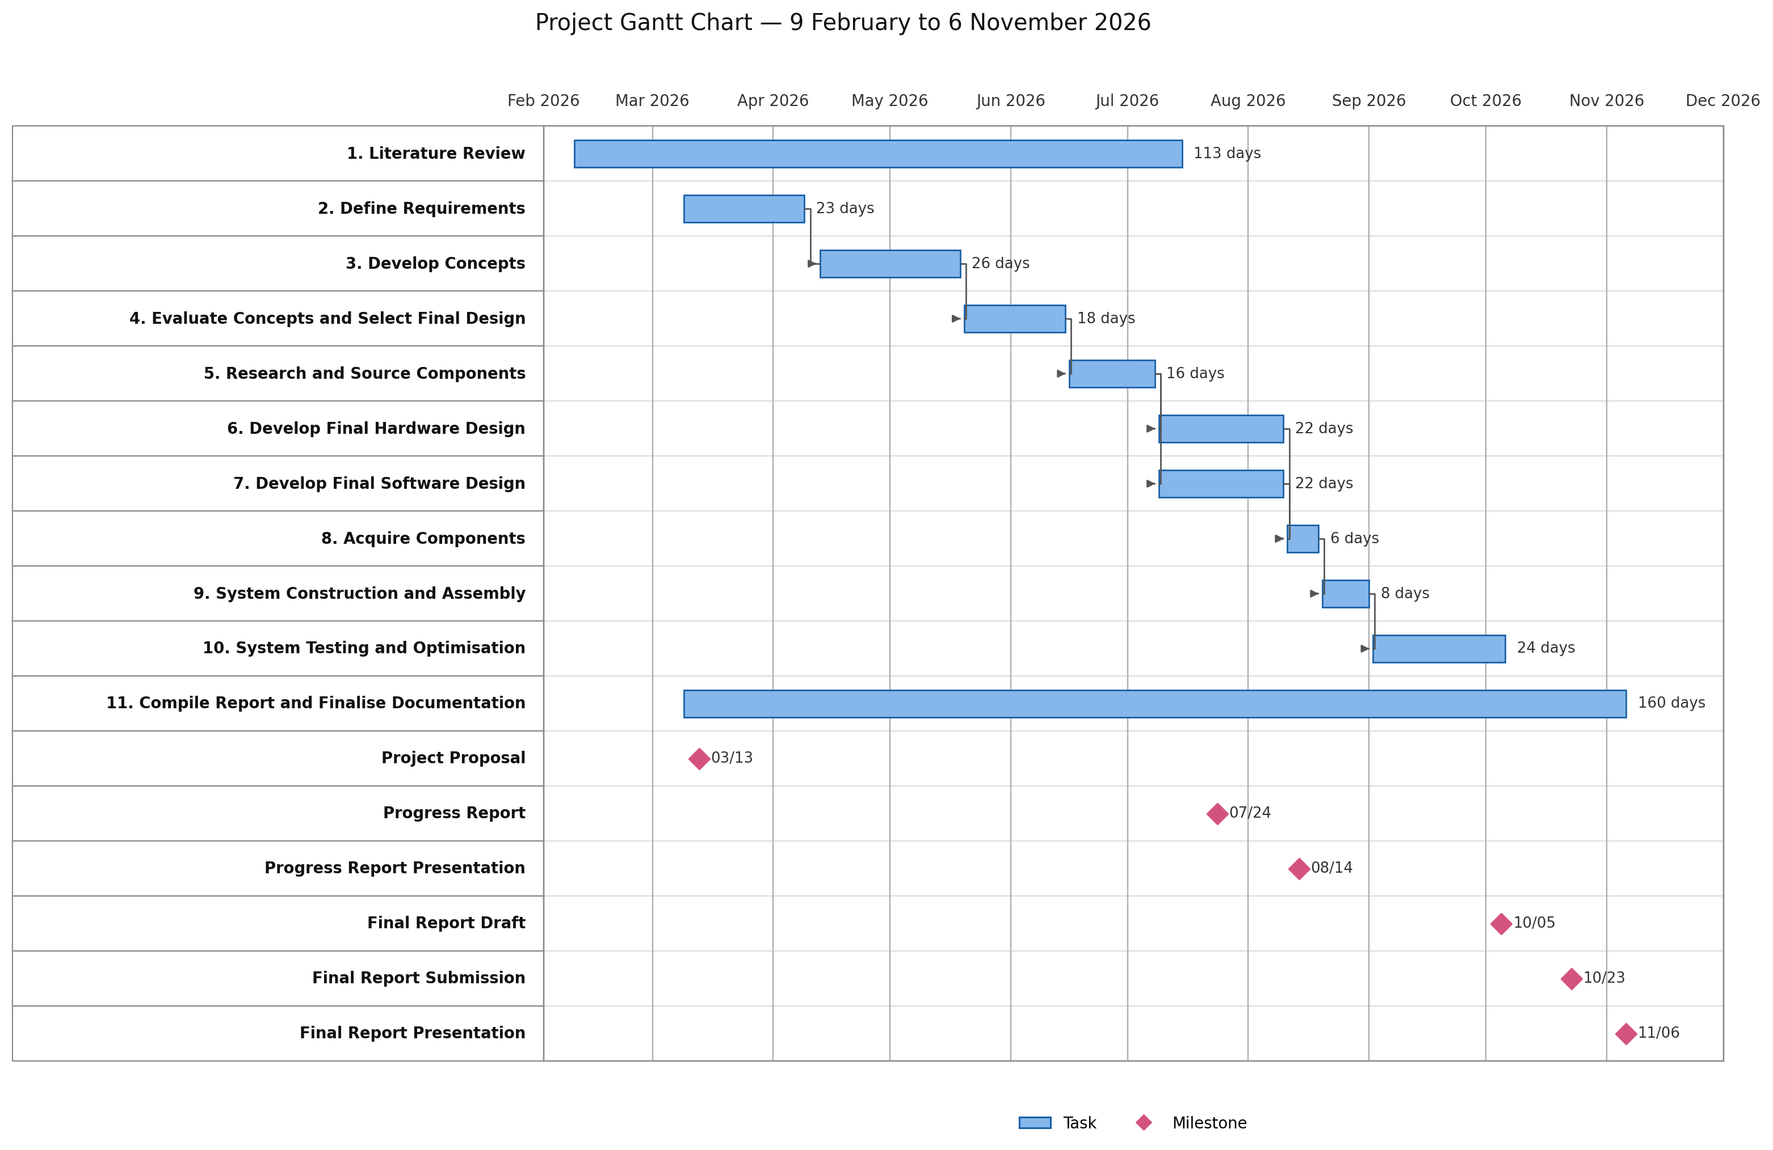

Figure 16: Gantt Chart of Planned Activities

- Technical Performance Measures
This appendix describes how the target values for the TPMs in Table 3 were determined.
1. Rotor operating speed
Derived from the display refresh requirement (TPM09) through the dual-arm geometry defined in §2.2. A diametric LED strip paints each angular column twice per revolution, so effective refresh = 2 × (rpm/60). The 700 rpm target yields ≈ 23 Hz and the 600 rpm lower bound yields 20 Hz, both above the 16 Hz image-formation bound (Paul et al., 2013; §2.2). Speed is held low to limit motor loading and noise (TPM10).
2. Total system cost
Set by the R5000 project budget stated in §1.1 and §1.3. The R4500 target reserves roughly 10 % contingency below the ceiling, against a commercial reference price of ~R8000 (Lumina, 2026; §1.3).
3. Unit total mass
Derived from the single-person portability requirement (FR14/SR09). 10 kg is taken as a conservative one-person carrying limit; 5 kg is the design target.
4. Swept display diameter
Derived from FR04 and the commercial reference size of ~450 mm (Lumina, 2026; §1.3). 400 mm keeps the image comparable to commercial units, while 300 mm is the minimum for a usable image.
5. Colour depth per LED
Derived from the full-RGB requirement (FR09). 8 bits per channel (24-bit colour) matches the bit depth of the supported JPEG/PNG inputs (TPM11) and of the addressable LED strip, avoiding quantisation loss.
6. Number of LEDs per arm
Sets the radial image resolution. The count equals the arm radius (200 mm, half of TPM04) divided by the strip pitch; the selected addressable strip (§6.4) gives ≈ 32 LEDs, with 25 the minimum for acceptable radial detail.
7. Number of discrete LED positions
Sets the angular resolution. 360 gives 1° per column, a natural division; 180 gives 2°, below which angular under-sampling at large radius degrades detail (Matungka et al., 2009; §2.6). At 700 rpm, 360 columns require a column update every ≈ 238 µs, within the microcontroller timing budget (§2.5).
8. Number of synchronised fan display units
Derived from the multi-fan objective (§1.2) and the modularity requirement (SR08/FR12). Two units is the minimum that constitutes synchronised operation. Note: reconcile with the single-unit detail design in §6 before submission (see scope note in review).
9. Display refresh rate
Derived from the POV literature in §2.2–§2.3. The image-formation lower bound is ~16 Hz (Paul et al., 2013) and the empirical single-arm flicker-free threshold is ~17 Hz (Lee et al., 2022). The dual-arm rotor at 700 rpm gives 2 × (700/60) = 23.3 ≈ 23 Hz. Note: Table 3 currently lists 24 Hz; update to 23 Hz for consistency with TPM01.
10. Fan display noise level
Derived from Regulation 5 of the Western Cape Noise Regulations, which limits machinery noise in residential areas to 50 dBA (Western Cape, 2013; FR15). Note: Table 3 currently gives the unit as dB with a range of ≤ 80; reconcile to dBA and ≤ 50 to match the cited limit.
11. Supports JPEG, PNG and GIF inputs
Derived from the user-upload requirement (FR07). These are the most widely used raster formats (Joopally et al., 2023), and GIF additionally carries the animation frames required by TPM12.
12. Animation frame rate
Derived from the animation-playback requirement (FR13). 12 fps is a common minimum for perceived continuous motion and 10 fps the lower acceptable bound; it is bounded above by the display refresh rate (TPM09), which it does not exceed.
13. Mains voltage supply compatibility in South Africa
Fixed by the South African single-phase mains nominal voltage, required for operation from a standard wall outlet (FR14/SR09).
14. Mains frequency supply compatibility in South Africa
Covers both unit price and local sourcing in South Africa. If the components are unavailable, the testing and optimisation phase will be affected. Fixed by the South African mains nominal frequency (FR14/SR09).

- Calculations
Intentionally left blank.
- Responsible Resource Use and End-of-Life Strategy
This appendix outlines the strategy for the responsible resource management and end-of-life treatment throughout the project. Resource management includes considerations for responsible sourcing and environmental impact during design, development and testing. The end-of-life strategy is guided by sustainability, where component reusability and recyclability are prioritised. Components are intended to be repurposed for future academic or development projects where possible. A summary of the resource management and end-of-life strategies is provided below.
Electrical components will be sourced from university-accredited suppliers to ensure quality, with preference given to local suppliers to reduce transportation distances and associated carbon emissions. Components available from the same supplier will be consolidated into a single order to minimise packaging waste and delivery cycles; international suppliers will be used only when specialised or unavailable components are required. Components will be selected for potential reuse in future academic or development projects, and will be handled, tested, and stored to preserve functionality and extend operational lifespan. Components damaged beyond repair will be directed to accredited electronic waste recycling facilities in accordance with environmental regulations, minimising E-waste and supporting responsible end-of-life management.
Mechanical components will be manufactured primarily within the university workshop, using recyclable and sustainably sourced materials to reduce environmental impact. Specialised components that cannot be manufactured conventionally will be produced through additive manufacturing, reducing material waste and enabling efficient production of complex geometries. Functional components will be assessed for reuse and stored for future academic or development projects; those that cannot be reused will be recycled where possible, including additive manufacturing polymers, or otherwise disposed of in accordance with applicable waste management and environmental regulations.
Software development will prioritise efficient use of computational resources, with code structured to minimise overhead, reduce energy consumption, and improve system performance. All developed software will be included in the final project repository to support reuse, transparency, and future development. Once no longer in operational use, the software will be archived using repository management tools to preserve development information for future reference, and redundant files will be securely removed to maintain efficient storage use.

Target based on Regulation 5 of the Western Cape Noise Regulations, which limits machinery noise in residential areas to 50 dBA (Western Cape, 2013).
JPEG, PNG and GIF were selected as they are the most widely used raster image formats, with universal support across operating systems, cameras and image editing software (Joopally et al., 2023). This ensures broad system compatibility for users when uploading images.

